1. Introduction and Background

3D Services Limited (3DS) is a business was incorporated in 2010, with a purpose of tracking people, vehicles and goods in transit. 3DS are experts in car tracking, fleet management, fuel monitoring and field staff surveillance. They provide solutions for tracking mobile assets and monitoring the asset users of motor cycles, cars, van, pickups, light trucks, heavy goods vehicle, earth-moving equipment, agricultural tractors and generators as well as lone workers, corporate employees and school children.

3D Services Limited employs 45 employees who are stationed at various geographical sites in East Africa. Each Employee is subject to a monthly performance management appraisal where their performance is measured. Each employee is given any number of key performance indicators (KPI), against which their performance is measured. Some KPIs are more important than others.

The company subscribes to the 4 disciplines of executions, of the Franklin Covey leadership fame, where it believed that the employee’s performance improves if they are in charge of the platform that records and tracks their appraisal ratings. The employee is empowered when they know the scores at all times.

Each employee is a line staff to a supervisor a.k.a line manager, to whom they report and to whom they submit their monthly self-appraisal scorecards. The line staff enters into the scorecards a percentage rating for each KPI. The line staff and line manager engage in a face to face performance appraisal meeting and discuss the scores entered into the scorecards. Upon agreement, the line manager approves the scorecard and signs it off in order to lock it from further editing.

In some instances, where a line staff supervises more than one line staff, one of the KPIs of a line staff may be calculated basing on the aggregated performance of all the line staff in the team. For example, KPI#1 of the sales manager may be calculated on the average performance of the sales team.

Some KPIs are more important than others, therefore a weighted grading system is used to calculate the performance of each KPI, basing on the percentage points assigned to the individual KPI item, and multiplying it with the percentage rating entered by the line staff, the total of the weighting totaling to 100%. ... Percentage points assign to individual KPI items are uniform across the teams in the company, for example KPI#1 = 33% weight // KPI#2 = 27% weight//KPI#3 = 20% weight//KPI#4 = 13%//KPI#5 = 7%.

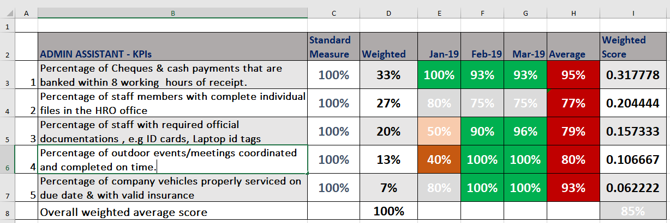

2. **Business Problem and Objectives**. This section outlines the business problem and objectives that the dashboard is intending to solve.

**Problem:**

Currently the company is using MS Excel, and the system is not reliable and prone to inaccuracies.

Each line staff has to create to create their own performance scorecard spreadsheet, and this often causes version control issues where it is not clear which copy is the current one.

Each line staff can edit and amend their own performance scorecard spreadsheet, and this often causes unauthorized changes to the KPI scores and deliberating tampering, which makes the performance management methodology unreliable.

Each line staff has to store their own performance scorecard spreadsheet, and this often causes losses of data, loss of consolidated performance records for individuals, departments and company at large.

Each line staff has to share the performance scorecard spreadsheet with their line manager via email, and this often creates version control issues and confusion regarding consolidated data.

The consolidated scorecard is tedious to manage because it involves duplicate data entry arising from the need to pick raw data from source spreadsheets from individuals.

The consolidated scorecards is not readily available to the top management because it is not online. This slows down decision making and inculcates a culture of poor performance management as a company.